

Consignee: STS WINDOW FILMS

Standard Delivery Specification

Product name: PVC VICENTI INTERIOR FILM (FIRE RETARDANT)

Issued date: 04 August 2022
Latest revised date: 01 September 2022
Received Notice  Consignee: STS WINDOW FILMS |  |  |  | Manufacturer: KCC Glass Corporation
Receiver | Reviewer | Approver |  | Manufacturing /Technical  Team Manager | QA  Team Manager
/ | / | / |  | / | /

Revision History
Date | Topic | Contents
01 Sep. 2022 | 3-3 Properties  Specifications | No.3 Initial viscosity → Initial adhesion strength
01 Sep. 2022 | 3-3 Properties  Specifications | No.4 Accelerated viscosity → Accelerated adhesion strength
01 Sep. 2022 | 4-2. Roll packing | Without side cap → With side cap
01 Sep. 2022 | 4-2. Feature | Size and feature changed (width X length X height, mm)  (170 X 170 X 1,255 → 207 X 207 X 1285)
01 Sep. 2022 | 6. Warranty Period | 1 Year warranty from after shipment (from port of loading)  → For 2 years from the date of production  (1 year for KCC Glass Corporation, after 1 year for the adhesive  company of KCC Glass Corporation’s OEM)
- Scope
This specification is for PVC VICENTI INTERIOR FILM product that is manufactured by KCC Glass Corporation and delivered to STS WINDOW FILMS “PVC VICENTI INTERIOR FILM” product shall apply by using.

- Application
Delivery specification applies for PVC VICENTI INTERIOR FILM after producing by KCC Glass Corporation and supply to STS WINDOW FILMS.

- Quality Standard
3-1. Measure
Properties | Specification
Width | 1220mm within -0 mm ~ +5 mm
Thickness | (0.41mm) within + 0.205mm, -0.0205mm
Length | 30m within +0.3M

3-2. Surface Specifications
No | Items |  | Specification | Remark
1 | Color |  | Base on Master sample (According to agreement for setting limit sample | By eyesight
2 | Solid Type | Fish eye | 1. Size : Below 0.5 mm²  Quantity : Less than 5 points / m  2. Size : 0.5 ~1.0 mm²  Quantity : Less than 2 points / Roll | KCG-AS-S-BD-I-250
2 | Solid Type | Foreign material |  | KCG-AS-S-BD-I-250
2 | Solid Type | Bubble |  | KCG-AS-S-BD-I-250
2 | Solid Type | Carbide |  | KCG-AS-S-BD-I-250
2 | Print Type | Defect |  | KCG-AS-S-BD-I-250
3 | Surface finish  (Wrinkle, dent) |  | None | By eyesight
4 | Flatness |  | Able to use without any problem | By eyesight

3-2-1. Foreign material, fish eye, bubble, carbide, defect Standard
Items | Inspection standard
Foreign material, fish eye, bubble, carbide, defect | 1. Size : Below than 0.5 mm²  Quantity : Less than 5 points / m  2. Size : 0.5 ~1.0 mm²  Quantity : Less than 2points / Roll  3. Size Above 1.mm² : Defect
Foreign material, fish eye, bubble, carbide, defect | The size confirmation is based on the optical microscope

3-3. Properties Specifications
No | Items |  | Unit | Specification
1 | Applied adhesive side(contamination, foreign material, unflated spread amount, overlapped R/P, bubble |  | - | None
2 | Fire retardant  (horizontal, vertical) | Flame time | Sec | Below than 3 sec
2 | Fire retardant  (horizontal, vertical) | Afterglow | Sec | Below than 5 sec
2 | Fire retardant  (horizontal, vertical) | Carbide length | ㎝ | Below than 20 cm
2 | Fire retardant  (horizontal, vertical) | Carbide area | ㎠ | Below than 30 cm
3 | Initial adhesion strength | SUS | N/25㎜ | More than 18
4 | Accelerated adhesion strength | SUS | N/25㎜ | More than 13
5 | Settling property |  |  | Not fail to adhesive
6 | Dimensional stability |  | mm | Below than 0.5
7 | Color |  | - | Base on Master sample (According to agreement for setting limit sample

- Packing
4-1. Packing
Items | Specification
Width | 1,220 mm
Product quantity per Roll | 1. Roll : 30m  2. Separated roll : Between 10m ~ 30m
Product quantity per Roll | * Standard : 1% additional quantity based on the quantity of roll

4-2. Roll packing
- Roll up the product from a core and cover by OPP wrapping paper then pack by below standard box (With side cap)
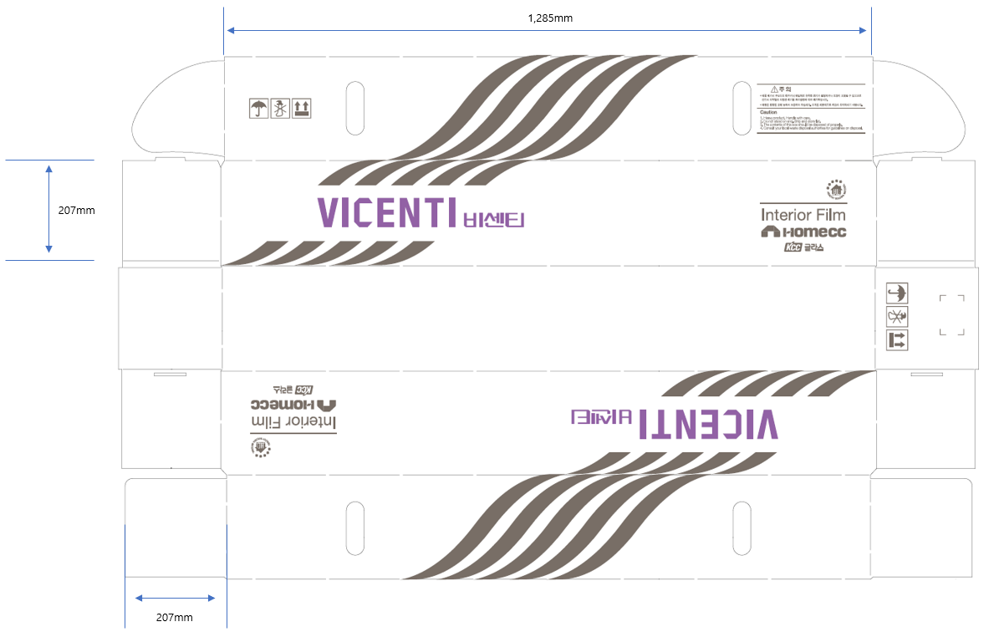

- How to identify and distinguish products
5-1. The following items are indicated on the product label.
- Product name: KCC glass VICENTI INTERIOR FILM
- Specification: Thickness & width
- Color No.: Product color code
- Lot No.: Half-finished goods/ Applying adhesive date.
- Length: Length per roll (unit: M)
- Inspection: Indicate an inspector

5-2 Label Format: As below picture / It is subject to change.
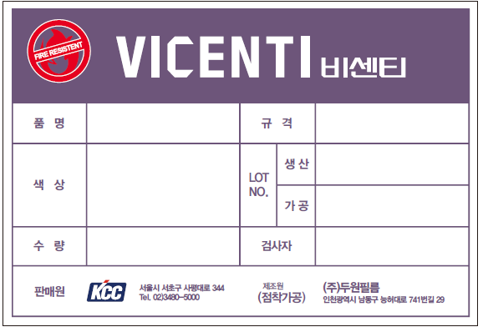
- Lot No.: (Ex. 220806 : 6th August 2022)

- Warranty period
For 2 years from the date of production (1 year for KCC Glass Corporation, after 1 year for the adhesive company of KCC Glass Corporation’s OEM)
※ No responsibility of defects and accident under circumstance.
- Using different purpose which is not included in agreement.
- Using the interior film and happen any defect after warranty period
- Any defect which is not included in this delivery specification and except for the agreement which are not arranged as document

- Product inspection during production
The customer is obliged to conduct surface quality inspection after unloading the product and notify us when a defect is found in the product. (When the product is defective, it is processed after agreement between the two parties.)

- Handling precautions
- Avoid direct sunlight and avoid exposure to external environments such as rain or snow.
- When storing the product, it should be stored at a temperature of 15℃ to 25℃ and a humidity of 50% in an indoor warehouse with good ventilation.
- It may be deformed when the product load or strong impact is applied.
- When the remaining amount is stored after using the product, it needs to be repackaged and stored to avoid exposure to dust or stains.

